CREATE JAVA APPLICATION

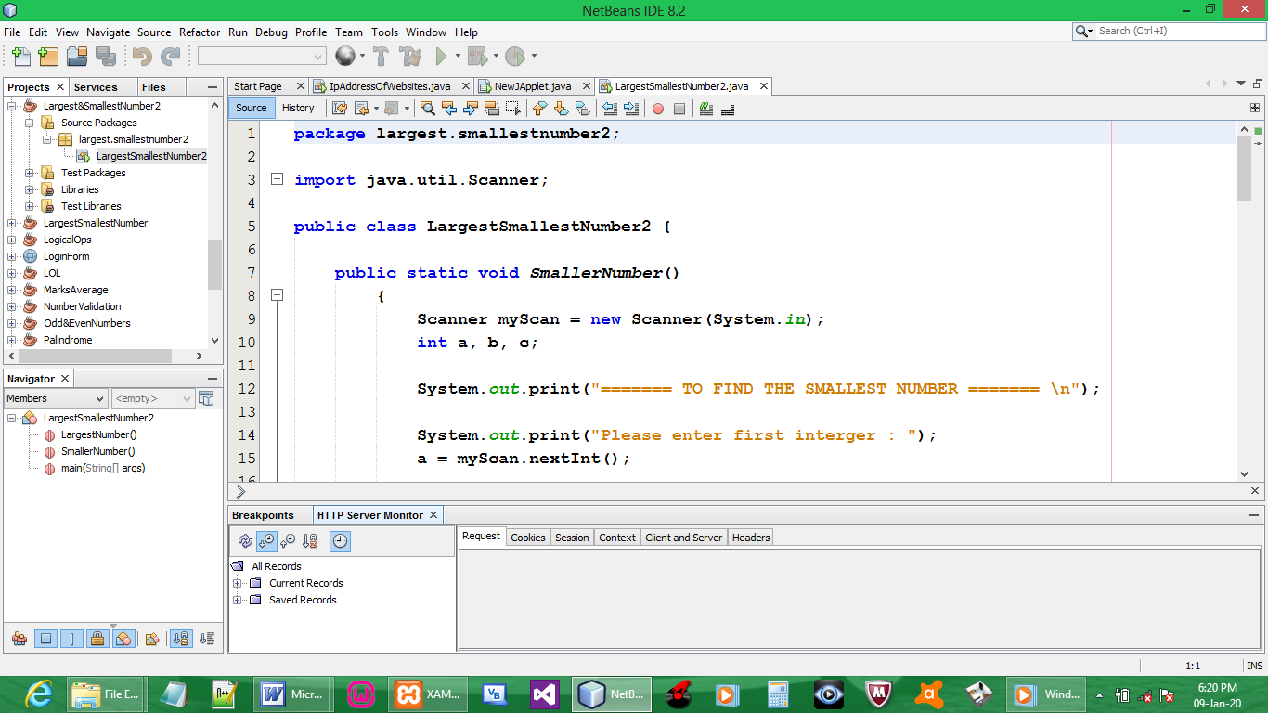

CODE:

package largest.smallestnumber2;

import java.util.Scanner;

public class LargestSmallestNumber2 {

public static void SmallerNumber()
{
Scanner myScan = new Scanner(System.in);
int a, b, c;

System.out.print("======= TO FIND THE SMALLEST NUMBER ======= \n");

System.out.print("Please enter first interger : ");
a = myScan.nextInt();

System.out.print("Please enter second interger : ");
b = myScan.nextInt();

System.out.print("Please enter third interger : ");
c = myScan.nextInt();

if(a < b)
if(a < c)
System.out.print(a + " is the smallest number");

if(b < a)
if(b < c)
System.out.print(b + " is the smallest number");

if(c < a)
if(c < b)
System.out.print(c + " is the smallest number");

System.out.print("\n");
}

public static void LargestNumber()
{
Scanner myScan = new Scanner(System.in);
int d, e, f;

System.out.print("======= TO FIND THE LARGEST NUMBER ======= \n");

System.out.print("Please enter first interger : ");
d = myScan.nextInt();

System.out.print("Please enter second interger : ");
e = myScan.nextInt();

System.out.print("Please enter third interger : ");
f = myScan.nextInt();

if(d > e)
if(d > f)
System.out.print(d + " is the largest number");

if(e > d)
if(e > f)
System.out.print(e + " is the largest number");

if(f > d)
if(f > e)
System.out.print(f + " is the largest number");

System.out.print("\n");
}

public static void main(String[] args) {
SmallerNumber();
LargestNumber();
}
}

OUTPUT:

